DOG PARKS AND OFF LEASH AREAS

Name | Location | Map
Oddies Creek Park | Wodonga Place, South Albury  Turn into Ebden Street entrance to park (off Wodonga Place), after 200m, turn left across a small bridge. | 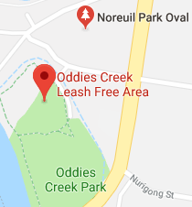
Alexandra Park | Corner of Cadell and Keene Streets, East Albury  Fenced agility park with off leash area | 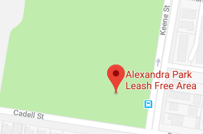
Logan Road | Logan Road. North Albury  Entry next to Bunton Park  Fenced agility park with off leash area | 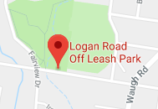
Poplar Drive Reserve | Poplar Drive, Lavington  Entry behind Heathwood Park | 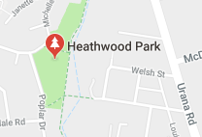
Gordon Street Reserve | Corner of Garoogong Road and Gordon Street, Springdale Heights | 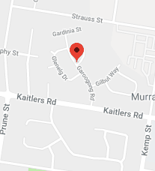
Belvoir Park | Reuss Road (near Church Street), Wodonga  Fenced agility park with off leash area | 